**ST. THEREZA NAMIRYANGO GIRLS’ BOARDING PRIMARY SCHOOL**

**END OF TERM I CONTINUOUS ASSESSMENT 2024**

**P.1 MATHEMATICS**

**TIME ALLOWED: 2 HOURS 30 MINUTES**

**NAME__________________________________________STM__**

**SECTION: A (40 MARKS)**

1. Add; 4  5 =

2. Name this set.

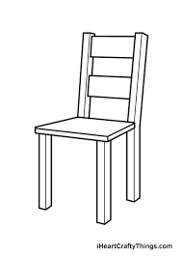   _________________

 

3. Fill in the missing number.

2, 4, 6, _____

4. Name the shape

___________

5. How many eyes do you have?

I have _____eyes.

6. Join these sets.

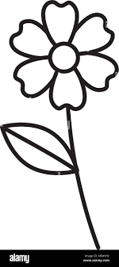   =

  

7. Count and write the number.

_______

8. Write the word for;

4 = ______

9. Take away

6 - 4 

10. Circle the smaller number.

9 4

11. Write the number between.

6, ___, 8

12. Write the symbol for:

five - ____

13. Count the legs.

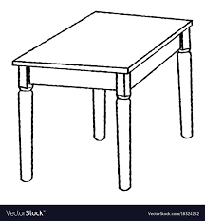

 ____

14. Arrange the numbers starting with the smallest.

8, 1, 5

____, ____, ____

15. When you add five and five you get

____________

16. Count the hands.

 ____

Hands

17. Write the day today.

__________

18. 1 tin 5 tins

 ____

19. Subtract :

2

2

20. Put together

1

6

**SECTION B**

21. **Write the number name.**

3 - ________

8 - ________

12 - ________

22. **Match the name of the object to its shape**

blackboard oval

coin triangle

an egg rectangle

samosa circle

23. **(a) Compare the sets using more or less** .

C D

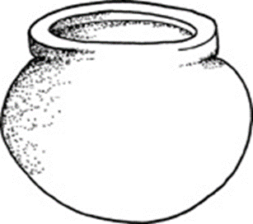  

  

Set D has _______ members than set C.

(b) Read and draw.

A set of 4 books.

24. **Add the numbers.**

(a) 2 6 

(c) 2

5

(b) 5 6

25. **Find the missing number**.

1

3 2  5

7

26. **Count and match**

2 legs

4 sides

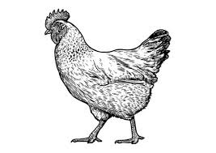

3 legs

27. **Count, write the number and its word.**

(a)  **   **  ____

 ___

_______

(b) 

 ___

_______

28(a)**Find the number between**

7, ___, 9

1, ___, 3

(b) **Write the number before.**

____, 10

29. **Match**

4 4  0

4 4  6

5 1  8

30. **Subtract;**

(a) 5 4 

(c) 2

 1

(b) 8 cups

 6 cups

cups

31. **Work out:**

(a) Four and two make ____________

(b) Three take away two is equal to ___________

(c) Seven flowers plus two flowers is equal to ________

32. **Fill in the missing numbers.**

1 3 9

6 8

**END**